JOINING AND ATTENDING A ZOOM MEETING: a participant guide

If you do not have the Zoom App already you will be prompted to download the zoom program/app from your app store on your device. I would suggest doing this prior to your class so that it is already installed on your device.

It looks like this:
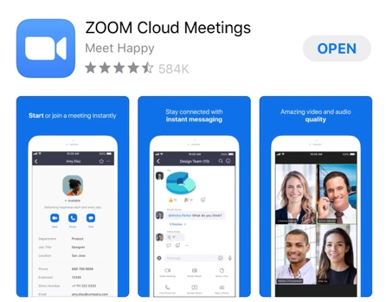
On the app link click on the get button.
Follow directions for signing in, put in your username and type in the password that you will be using, and this will be establishing your app on your device.

When you want to join a zoom meeting you will receive an invitation from the host in your email or text messages. Click on the link just under where it says Join Zoom Meeting.

There is also a meeting id # and can be used if prompted to do so, but you more than likely will not be asked for it.

You will be brought to the meeting screen, say Hi to everyone. Your host will most likely be there but if no one is there just be patient until others join.

You will receive directions on what to do once you enter the viewing screen. At the top of the screen you will see small boxes with everyone who is attending.

You then will be asked to Mute yourself when you are not speaking and there is a little microphone icon on the bottom left of your screen, just click on the symbol and you will be muted. On the top right of your screen there is the option to have gallery view or speaker view and your instructor will guide you as to what that setting should be for you. If you want to speak just tap the mute button and you will be allowed to speak. Your image will become large in the screen when you are talking and diminish once you are finished. When you stop speaking tap the mute button to turn off your sound. Your instructor will guide you on what to set this at during the class.

Rename yourself with your name if it does not appear. Position your camera on your device so it is stationary and shows your full face

Have a great time!!!

